Cyara User Guide:

**Creating and Running Campaigns**

When you create a new Campaign, the Channel type will default to either Voice or the Channel type for which you have active Plans. When you change the Channel selection, the associated Plan selection will be regenerated and filled with active Plans for the chosen Channel.

Once you have chosen the Plan, the page will be reloaded to display a page specific to the chosen Plan type.

To create a new Campaign, perform the following steps:

1. From the main menu, select Campaigns and then click New Campaign. A New Campaign screen as shown below appears based on the Associated Plan:

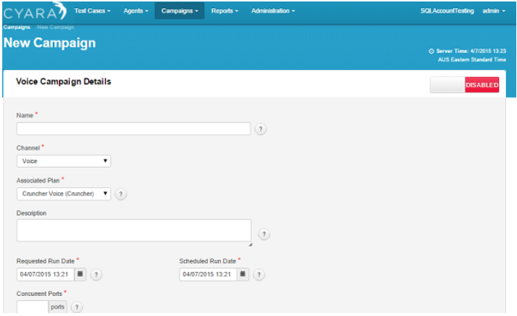

1. Enter the Name of the new Campaign.

This should be as descriptive as possible because it is used as the report title.

1. Select the Channel from the drop-down list.

The relevant fields appear as per the selected Channel.

* + Email Channel; An Email Test Case can be used for Pulse and Cruncher Campaigns.
  + SMS Channel: An SMS Test Case can be used in conjunction with an Outbound Campaign to test messaging being sent by your organization to your customer's mobile phone

1. Select the Associated Plan from the drop-down list.

The available options depend on your Plan Subscription – Cruncher (load testing), Cruncher Lite (load testing), Pulse (quality assurance), Virtual Agent (agent simulation), or Outbound.

1. Enter a brief description for your Campaign in the Description field.

The Last Run field is automatically populated when the Campaign is run. It is not applicable when creating a new Campaign. The Current Status field is automatically populated with the status of the current or previous Campaign Run. This does not apply to new Campaigns.

1. Select the Requested Run Date.   
   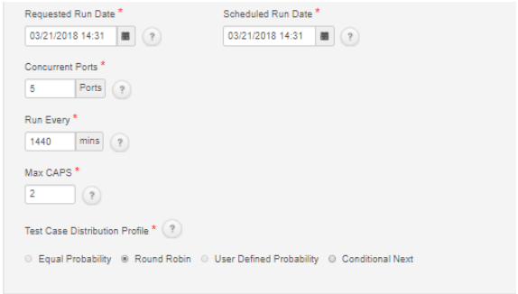

This is the date and time when the Campaign is scheduled to be run. Note that this is only an indicative time, as Cyara may vary the time depending on the load on the system and other scheduled Cruncher runs.

1. Select the Scheduled Run Date. This is the actual date and time the Campaign is scheduled to run.

Note: Cyara will make every attempt to allow the Campaign to run when requested. However, the actual time the Campaign Run takes place may vary. Cyara will endeavor to notify the users of the actual Campaign run time, and the actual Campaign run time will also be displayed on the Campaign in the Cyara Web Portal.

1. Enter the Concurrent Ports. This is the number of concurrent ports/sessions to be tested. The maximum number of ports/sessions that can be tested simultaneously is determined by the Plan Subscription. The number of ports specified in the Plan cannot be exceeded.

In the case of a Web Campaign, this is Concurrent Sessions.

1. Enter the value for the Run Every/Run For field.   
   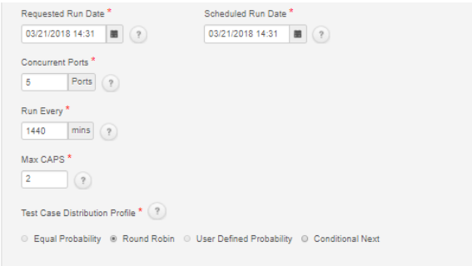

The Run For field is applicable only to Cruncher and Outbound.

* + Cruncher: The value set here has two modes of operation depending on whether the radio button is set to Mins or Calls.

If the Mins radio button is selected, the Campaign will run for the specified duration in minutes. For example, if you set the Run For value to 60 and select the Mins radio button, the Campaign will run for 60 minutes.

If the Calls radio button is selected, the Campaign will run for the specified number of calls. For example, if you set the Run For value to 200, it will run the Campaign for 200 calls.

Note: The number of calls to be made per Campaign has to be equal to or greater than the number of concurrent ports.

* + **Outbound**: The Outbound Campaign will run for the number of Mins specified. This is the only option available for an Outbound Campaign.

1. Enter the Ramp-Up Time. This field is only applicable to Cruncher.

This refers to the duration over which the number of concurrent calls generated will be progressively increased at a constant rate (the ramp-up rate) until the specified number of concurrent ports is reached.

The Ramp-Up Time is inversely proportional to the rate of call generation, so a low value will result in calls being generated at a high rate, and a high value will result in calls being generated at a low rate. Set a low value (0-5) to simulate “avalanche” calling and a high value to pace the calls over a longer period of time. This value overrides the Min/Max pause time set in the associated Test Cases for the Campaign. For example, for a 100 concurrent ports Campaign and a Ramp-Up Time of 50 seconds, the ramp-up rate is two concurrent calls per second (100/50). Therefore, two calls will be placed initially, four sustained calls after the next second, six calls, and so on, until the sustained limit of 100 concurrent calls is reached.

1. Enter the Frequency. This field is only applicable to Pulse.

The frequency of the Test Cases run is specified in minutes. The maximum gap between two consecutive Campaign Runs can be 1440 minutes (24 hours).

1. In the case of Voice Campaigns, enter the Max CAPs value.

This number specifies the Maximum CAPs value for the Campaign. It cannot exceed the value specified in the Account. This only applies to Inbound Testing.

1. In the case of Web Campaigns, enter the Max APS value.

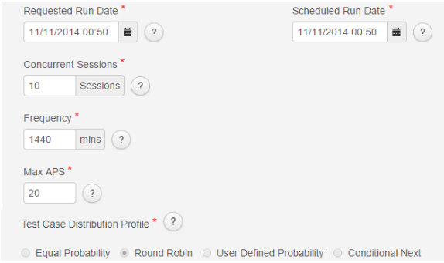

This number specifies the Maximum APS value for the Campaign. It cannot exceed the value specified in the Account. This only applies to Inbound testing.

1. Change the Status to ‘ENABLED’ to make the Campaign active. This also changes the Save Details button at the bottom of the page to a Save & Run button.

**Parent topic:** [Campaigns](http://cyaraprod.uhg.com/CyaraWebPortal/ContentAuthenticated/UserGuide/Campaigns.html)

**Running a Campaign on a Schedule**

This feature is available in Pulse, Pulse Outbound, and Virtual Agent Campaigns.

Campaigns are scheduled to run 24 x 7 by default. However, the user can specify time intervals when the Campaigns should run. This is useful when the IVR application is only available to customers at specific time periods. For example, 8am to 8pm Monday to Friday.

1. When you are creating a new Campaign, if you have selected either a Pulse or Pulse Outbound or Virtual Agent Campaign, you see the Schedule option as shown:   
   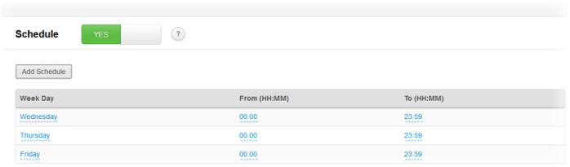
2. Click the Add Schedule button to add a specific time interval to the schedule of the Campaign. A row is added to the schedule table with options to specify the ‘Week Day’, ‘From’ time, and ‘To’ time. Note that the specified time intervals should not overlap as the Cyara Web Portal will not allow more than one instance of a Campaign to be running at a time.
3. Specify the Week Day, From (HH:MM) time, and To (HH:MM) time.
4. To make changes to a Schedule, click the field to edit and make the changes directly.
5. Click the red trash can icon on the right-hand side to delete a row from the schedule table.

**Adding a Pause to a Schedule**

This feature is available in Pulse, Pulse Outbound, and Virtual Agent Campaigns.

To avoid receiving alerts during a planned maintenance window, Campaigns can be paused. Any Campaign type that can be scheduled can also be paused. It is important to note that adding a pause means a Campaign will not start during the specified pause window, but will keep running if it was already running. A pause can be added with or without a weekday schedule.

1. When you are creating a new Campaign, if you have selected either a Pulse or Pulse Outbound or Virtual Agent Campaign, you see the Schedule option as shown:
2. Click the Add Pause button.
3. Using the calendar drop-down, specify the From (Date & Time) and To (Date & Time) for the pause.
4. If required, add a description of the reason for the pause in the Note box.

Note: Only pauses that are currently in effect or scheduled to take effect will be displayed here. Historical pauses are not displayed and cannot be edited.

**Configuring Pulse Campaigns for Cyara Recording Validation**

Cyara Recording Validation provides the ability to validate call recording platforms. By periodically generating a synthetic call, the Platform will retrieve the corresponding recording and perform checks and tests to ensure it exists and is of sufficient quality and fidelity.

The Recording Validation feature enables the Cyara Platform to:

* Make periodic synthetic calls to the customer call center.
* Retrieve a call recording with a synthetic call it has made using call details.
* Subject retrieved agent call recording audio to a quality analysis.
* Save the results of the recording validation with the results of a Pulse test call.
* Compare audio from each agent call recording and the synthetic call.

This feature is only configurable for Pulse Inbound Campaigns, and it works with either a Cyara Virtual Agent or a real agent. When you are creating a Pulse Inbound Campaign, you can enable the setting for Recording Validation as shown below:

1. When you select the Check Recording Quality checkbox, the bottom panel is enabled where the MOS Threshold, Duration Deviation Threshold, and Silence Threshold can be specified.
   * **MOS (Mean Opinion Score)** is a subjective measure of the perceived audio quality. Specify the Satisfactory, Success, and Failed Score Thresholds using the slider.
   * Duration Deviation Threshold is the percentage difference between expected Call Length and the recorded audio length. Specify the Satisfactory and Failed deviation percentage thresholds using the slider.
   * Silence Threshold is the percentage of perceived silence in the recording. Specify the Satisfactory and Failed Silence percentage thresholds using the slider.
2. To select the Agent recording environment, select the drop-down list under Agents > Environment/Server and select the Agents. Only agents configured under this environment will be displayed here.
   * Select the Agents from the list of Available Agents on the right-hand side and click Add to Campaign.
     1. To select or deselect multiple Agents, press the CTRL key.
     2. To select an Agent, hold the SHIFT key. Selecting another Agent selects all the Agents between the two selections.
     3. To remove an Agent from the Associated Agents, select against the Agent to be removed and then click the Delete button.
   * Search: You can search the Agents for those that match a user-specified string.
     1. After you enter the search criteria and click the Search button, only those Agents with Names that contain the search string will be displayed.
     2. To revert to the full list of Agents, click the Reset button.
3. To save the recording, select the Save Recording Audio checkbox. If this checkbox is selected, the audio will be presented on the Test Result Details page and can be played in sync with the regular call recording. See the Reporting topics for more details.

**Test Case Distribution Profile**

The **Test Case Distribution Profile** is configurable for Cruncher, Outbound, and Pulse Campaigns. Note that not all the options are always available. Other Campaign types use Round Robin. The Test Case Distribution Profile panel is shown below:

* Equal Probability: Equal Probability Test Case Distribution will give each Test Case associated with the Campaign equal probability of being run. Test Cases are selected at random from the associated Test Cases with equal weighting.
* Round Robin: Round Robin Test Case Distribution will run each Test Case in turn.
* User Defined Probability: User Defined Probability Test Case Distribution gives each Test Case associated with the Campaign a user-configurable probability field. Associated Test Cases are selected at random with the weighting specified by these configured probabilities. Each Test Case has an editable property next to it in the Associated Test Cases list. The total of all Test Case probabilities (expressed as a percentage) must add up to 100.
  + When you click the Save Details or Save & Run button, an error will appear if the values do not add up to 100.
* Conditional Next: The **Conditional Test Case Distribution Profile** is also known as Conditional Campaign and can be used on Pulse Campaigns.

If the Conditional Next option is selected, then Test Cases are executed conditionally starting from the top. Each subsequent Test Case will execute only if the previous one has Failed or been Satisfactory.

For example, in a Campaign, the Test Cases will be ordered from 1 to n. Test Case 1 is the only one that is scheduled to run. If Test Case 1 fails, then Test Case 2 will run and if Test Case 2 fails, then Test Case 3 will run, and so on.

Alerts will be generated through the Pulse listener. If required, alerts can be generated on each Test Case failure.

Note: Data driven Test Cases are not fully supported and it will only run the first data scenario of each Test Case as of now.

Associated Test Cases: Highlight the Test Case you want to use for the Campaign.

To do this, click the existing Test Cases in the Available Pool, then use the Add to table below button to move the Test Cases to the Associated Test Cases table. If there are no Test Cases, they will need to be created and validated first.

1. To select or deselect multiple Test Cases, press the CTRL key.
2. To select a Test Case, hold the SHIFT key. Selecting another Test Case selects all the Test Cases between the two selections.
3. To remove Test Cases from the Associated Test Cases, select the Test Cases to be removed and then click the Remove button.

Note: The Available Pool will display only Outbound Test Cases when the Associated Plan type is Outbound and will display only Inbound Test Cases for other Plan types.

1. Once the Campaign is configured, click the Save Details or Save & Run button.

Search: You can search for the Available Pool of Test Cases for ones that match a user-specified string.

* After you enter the search criteria and click the Search button, only those Test Cases with Names that contain the search string will be displayed.
* To revert to the full list of Test Cases, click the Reset button.

**Velocity Campaigns - Synchronised Setting**

When you are creating a Voice Inbound Velocity Campaign, you can enable the Synchronised setting; this will provide information to an Agent Campaign to match up the Voice Call with the Agent interaction and perform attached data validation.

If your Campaign has Voice Test Cases with an agent step, you must set the Campaign to **Synchronised**. Before running the Inbound Campaign, the corresponding Virtual Agent Campaign must be started. This will ensure the calls are answered by virtual agents which will synchronise with the Test Case and validate the CTI attached data as specified in the Test Case.

To enable the Synchronised setting, set the Synchronised field to YES as shown:

Note: This setting is available only for Velocity Campaigns.

See the [Adding an Agent Step for Velocity Campaigns](http://cyaraprod.uhg.com/CyaraWebPortal/ContentAuthenticated/UserGuide/Entering_Voice_Test_Case_Steps.html#task_C7E80B00DB6647848746538233FF7207) and [Behavior activity type](http://cyaraprod.uhg.com/CyaraWebPortal/ContentAuthenticated/UserGuide/Supported_Voice_Types.html#task_C3B131C19EF843699956577F718140F7) topics for more information